

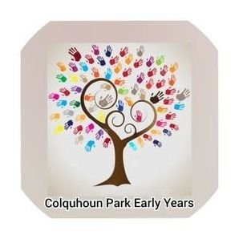
Standards and Quality Report
2025/26

Context of the Centre
Colquhoun Park Early Years Centre is based in Bearsden West and is an integral part of the wider Colquhoun Park Primary School community.

Our care inspectorate registration affords us the capacity to accommodate 40 children aged 3 to 5 years and 10 children aged 2 years, in centre, at any one time.

We currently have 38 children aged 3 to 5 years and 2 children aged 2 years on our role.

50% of our children are fee paying.

A few access additional hours as allocated at a Locality Panel meeting.

100% of children attending centre, eligible for 1140 funded hours have been offered, and are receiving their entitlement.

We are open between the hours of 8am and 6pm, Monday to Friday, 50 weeks of the year. Closing only for public holidays, in service days and the period in between Christmas and New Year.

Our staff team currently consists of.

- Head Teacher
- Depute Head of Centre
- Senior Early Years Worker
- 4 full time Early Years Workers
- 8 part time Early Years Worker
- 1 part time/term time Early Years Worker
- 2 job share Teachers.
- 2 job share Clerical Assistants.
- Housekeeper
- Early Years Support Worker

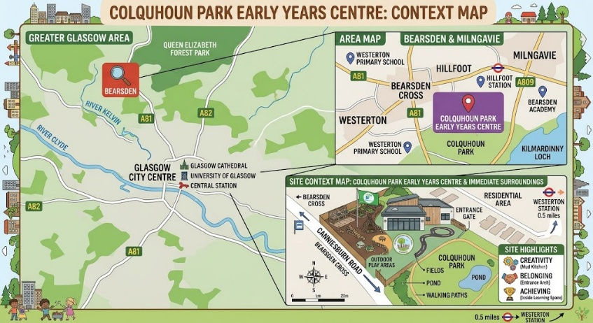

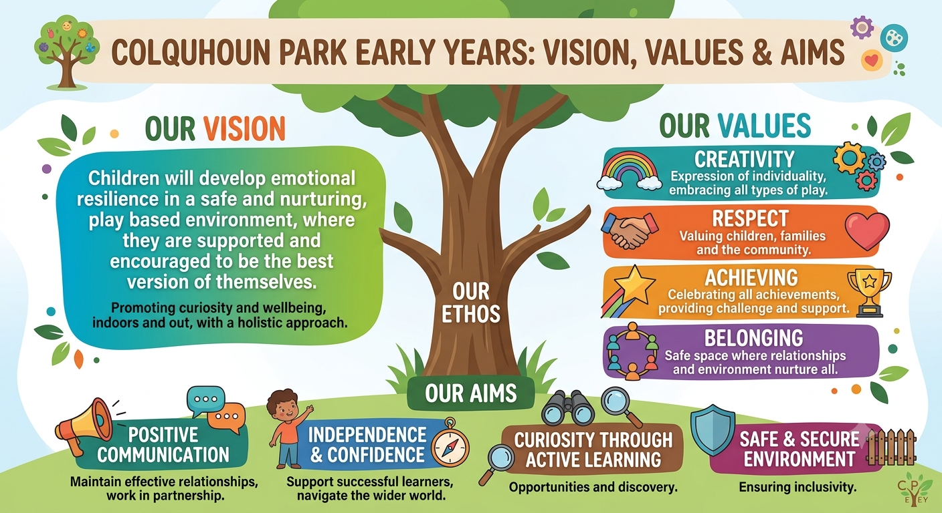
Centre priority 1: Up, Up & Away
NIF Priority  Improvement in children and young people’s health and wellbeing | QIs  Leadership of Continuous Improvement  Wellbeing, Inclusion and Equality
Progress and Impact: Working parties were established in August to focus on the implementation process of the Up, Up & Away framework within CPEYC.

All staff within the working party familiarised themselves with the document and began to test ways in which a successful and meaningful introduction to UUA could be initiated.

In January staff revisited their implementation plan, recognising that for implementation to be effective it would be beneficial to focus on one area at a time, embedding this in practice before moving on through the document.

Literacy at home questionnaires were sent out to some of our families, data collected returned information which determined the direction staff were next going to take.

Focus was set on the introduction of the literacy caterpillar into centre. Data collected from family input identified that most of our children did not visit their local library, with almost all also indicating they did not own or make use of a library card.

Staff shared information via video with families on the introduction on the literacy caterpillar which created the foundation for the home link working.

https://www.youtube.com/shorts/Foqvald_e-4

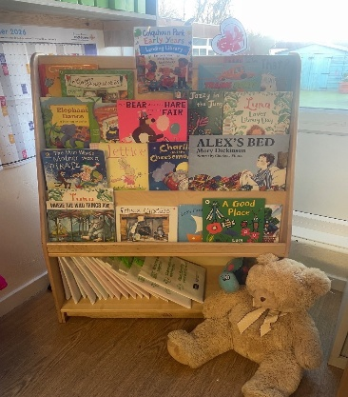
In March 2026 staff introduce Colquhoun Park EYC lending library and our Story star wall of fame. All most all families got involved with this initiative, children borrowed books and with their adult’s support used the QR codes to submit a book review.
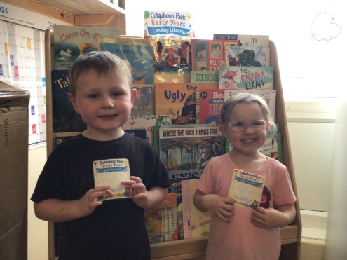
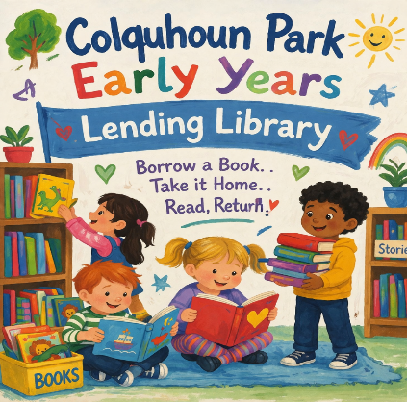

Since the introduction of our lending library, we have seen in increase in both family engagement, evidenced through feedback and book reviews, and children’s interest in sharing stories with the adult at home. Based on children’s high engagement with this initiative and the self-sufficiency of children collecting their library card and book at the end of the evening we believe that this initiative has been implemented successfully in centre and has positively impacted both literacy at home and family engagement.

A report collated from joint inspection with HMIE and Care Inspectorate, in April 2026 stated;

“Staff have a very good understanding of the socio-economic context in which children live. They ensure all children have equal opportunity to extend their learning. For example, staff identified that some families were unable to access the local library. In response, they set up a lending library within the setting. This is helping all children and families to engage with a wide range of story books to share together.”

Next Steps: Re-establish links with local library and care home to enhance literacy opportunity within the local community.

Continue with the effective implementation of the UUA framework in CPEYC;
- optimise opportunity for the child (section 3)
- planning to meet children’s needs (section 4)
Centre priority 2: Curriculum Planning & Tracking – Children’s Rights
NIF Priority Placing the human rights and needs of every child and young person at the centre  Improvement in children and young people’s health and wellbeing  Improvement in attainment, particularly in literacy and numeracy. | QIs  Staff Skills Knowledge Values and Deployment  Curriculum  Leadership of Continuous Improvement
Progress and Impact: Working parties were established in August to focus on the effective curricular introduction of the UNCRC Rights of the Child within CPEYC.

Staff were directly tasked in creating a road map of delivery in which children and their families could learn about Rights, developing their understanding whilst creating a rights respecting environment in centre.

Questionnaires were sent out to all staff members to obtain a better understanding of their foundational knowledge of children’s rights and their confidence in supporting and developing children’s understanding. 64% of staff stated they would be confident in supporting children understand their rights, whilst 36% were unsure. 100% of staff believed that they would benefit from further training on Children’s rights.

In response to these results staff within the working party began to collate information. First considering the articles which most reflected centre practice. Staff identified 4 articles as the starting point for introduction.

• Article 24 – The Right to Be Healthy
• Article 12 – The Right to Be Heard
• Article 28 – The Right to Education
• Article 31 – The Right to Play

Each article was coloured coded to support visual identification throughout centre, these colours provide backing to the UNCRC logo and can be found throughout the children’s discovery logs and wall displays.

Information on each article was broken down and shared with staff and families to supported understanding on how these rights can be supported in daily life tasks and practice.

https://blogs.glowscotland.org.uk/ed/colquhounparkearlyyearscentre/2026/02/06/childrens-rights-working-together-for-change/

A report collated from joint inspection with HMIE and Care Inspectorate, in April 2026 stated;

“Staff were enthusiastic in their interactions and shared fun experiences with children. For example, they joined in reading stories, building towers and having pretend tea parties with children. This meant staff valued and supported children’s rights and wellbeing.”

“Staff are beginning to use the language of children’s rights well to support children to manage their emotions and include others in their play.”

“Management supported professional development through regular reviews, self-evaluation, and improvement planning linked to the service improvement plan. This led to staff working together through focused working parties to improve agreed areas of practice. As a result, children were supported by a confident staff team who understood child development, respected children’s rights, and provided stimulating environments and experiences.”

Next Steps: Build on the foundations of the early implementation phase. Collect and analyse data which measures the impact of developing understanding and a rights-based approach to learning throughout centre.

Centre priority 3: Environment
NIF Priority Placing the human rights and needs of every child and young person at the centre  Improvement in children and young people’s health and wellbeing | QIs  Children Experience High Quality Spaces  Leadership of Continuous Improvement  Wellbeing, Inclusion and Equality
Progress and Impact: Evaluation of children’s play space and learning opportunities was carried out in Summer of 2025 by SMT. Consideration was given to the offer of differentiation throughout both the indoor and outdoor environment for each age and stage of child who attends centre.

In August 2025 SMT supported staff, using information taken from environmental audits, observation and professional knowledge, to redevelop the environment both indoors and out.
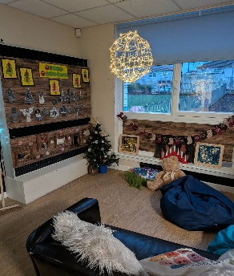
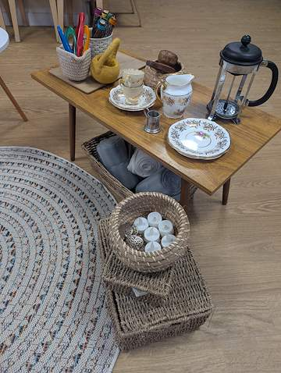
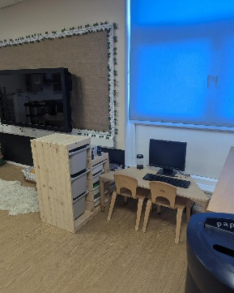
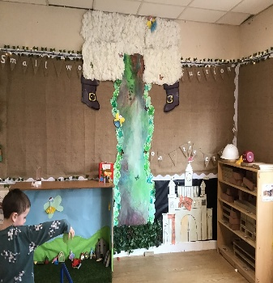
Areas are now further defined and resourced with age and stage appropriate items which deliberately provoke engagement, curiosity and exploration for all children in centre.
Almost all staff attended refreshing training on play and provocation. Continuous personal knowledge logs suggest that staff will use these skills learned to enhance the environment, respond to play cues and scaffold in the moment learning.

After consultation it was the decision of staff to trial themed group learning experiences for all, ensuring children remain central to leading their own learning, an 8-week cycle has been created which consists of;

Exploration (week 1), Children’s choice: Voting (week 2), Children’s Voice: What do we want to learn (week 3), Learning opportunity and experience (week 4-7), Children’s Voice: What have we learned (week 8, measurable impact)

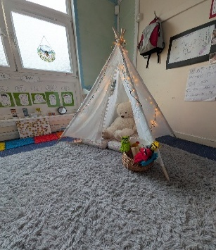
This type of working supports immersive exploration to take place across centre. All children are offered the opportunity to play in a curricular rich environment where daily interdisciplinary learning is recognised and nurtured by the adult. The adult’s role to offer a balance of pre-planned and in the moment learning opportunities respects children’s autonomy to take the lead their own learning. All staff use provocation to provoke curiosity and self-exploration for children.

Initial findings suggest that almost all children have presented as having and increased depth in knowledge and understanding in the area which have been explored using this method. Parental engagement has also supported these findings and staff initial observations “It’s been great and so much fun for our girl
She has been talking to much about the planets and wanting to go into space”

Working closely with the school the decision was made for the EYC to be given additional space to create a calm environment away from the playrooms which would aid in the offering of support for emotional wellbeing and regulation. A breakout space has been established for all children to access when they feel they need some calm in the fast pace of the day. This room has proved to be a very welcome addition to our centre with all children making use of it for activities such as PATHS (promoting alternative thinking strategies), well being check in, 1:1 or teaching talking sessions.
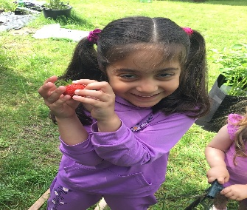
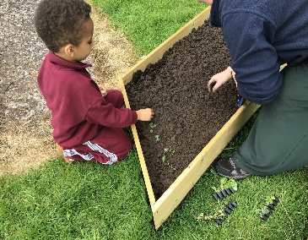
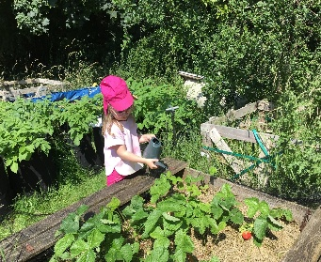
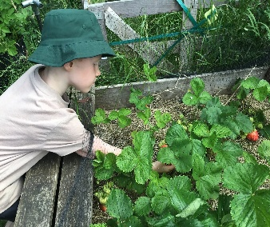

Continuous play provision areas were established outdoors, and a growing space was re-established in centre. All children are giving the opportunity to plant, grow, tend and taste fruits and vegetables grown in centre. Family engagement session was held which focused on planting, all families who joined were gifted the potted flower that they planted to take home.

Refurbishment and maintence works carried out by local authority seen centre gain an upgraded nappy change and personal care space for our children, as well as a new roof and full centre repaint.

A report collated from joint inspection with HMIE and Care Inspectorate, in April 2026 stated;

“Staff have developed attractive indoor and outdoor learning environments successfully. They provide a wide range of open-ended and natural resources which children use well to be curious and creative in their play. Almost all children are highly motivated and sustain engagement effectively in the wide range of learning experiences on offer. All staff have a strong understanding of child development. They consider the flow of the daily routines carefully to ensure they meet the wellbeing needs of all children effectively.”

“Children engage effectively in motivating learning experiences indoors and outdoors. They are developing their independence and confidence very well. Children enjoy exploring and being creative as they play and learn. They are happy, settled and secure in the early years centre.”

Next Steps: Re-establish mini explorers and forest programme into centre delivery planning.
Continue to develop growing space for children, introduce seed to fork programmes for all.

Progress in National Improvement Framework (NIF) priorities
Closing the attainment gap between the most and least disadvantaged children and young people;
At Colquhoun Park Early Years we believe in equity for all. We strive to ensure all our children and families receive the same nurturing, high quality learning provision regardless of socioeconomic backgrounds. We offer an accessible approach to all and recognise all children as individuals. Wellbeing assessments are carried out on all children within 6 weeks of them attending centre. Where potential barriers to learning are identified, appropriate supports are put in place, working in conjunction with the family and where necessary additional agency, to ensure that barriers are overcome, and children are supported to achieve their full potential.

Early years teaching staff carry out termly assessments for almost all pre-school children based on early level numeracy and literacy outcomes. Assessment results are used to create numeracy and literacy groups where children will work closely with teachers to develop skills in both areas. Early years workers use numeracy and literacy progression frameworks as a tool to monitor children’s progress and as a guide for identifying both support needs and challenge steps. Short term learning cycles are set for all children aged 3-5yrs based on their individual literacy and numeracy stage of development. Next steps are assessed at the end of each short-term learning cycle to ensure progress is made by all.

Improvement in children and young people’s health and wellbeing
All Children have the opportunity to take part in weekly wellbeing check-in. The Colour Monster is used as a vehicle for the learning and developing of emotional literacy skills. All children are encouraged to explore and discuss their emotions with their peers and adults in the centre. The introduction of this begins 2 years onwards. In doing so we promote an environment in which children are attuned to their emotions, and that of others, recognising within their surroundings the impact others may have on their health and wellbeing.
We encourage children to listen to their bodies, offering opportunities to access a calm, quiet environment in which children can step away from the fast pace of the day. In this area we have children who sleep, story times, mindfulness sessions, yoga, jigsaws, colouring etc. Lights are dimmed and the activities and atmosphere are set to promote a calming environment.
An additional area of calm away from the playrooms has been created which offers a break out space to support emotional wellbeing and regulation.

Placing the human rights and needs of every child and young person at the centre
Nurture is at the core of our pedagogy. We recognise that all children are individual and each person in their life plays a role in influencing their journey. We use the principles of GIRFEC and my world triangle to ensure that each child in our care is Safe, Healthy, Active, Nurtured, Achieving, Responsible, and Included. We pay attention to the stage of the child and create opportunity individual to their need, supporting them to reach their full potential. Children’s passports and personal learning plans are used to establish individual learning plans for all children in centre. We strongly believe in the fundamental right to play, be heard, be healthy and to be educated. We work hard at promoting and advocating these for every child in our care. This year particularly we worked together to support children in understanding these rights, giving them the tools and knowledge to promote these for themselves. We believe play is the universal language of children and use this as a vehicle to spark curiosity, enquiry and engagement in all.

Self-evaluation of The Quality Framework
Quality indicator | Centre  self-evaluation | Inspection/ Authority evaluation
Staff skills, knowledge, values and deployment | Very good | Very good
Learning, teaching and assessment​ | Very good | Very good
Children’s progress | Very good | Very good
Nurturing care and support | Very good | Very good

Summary of Centre Improvement priorities for Session 2026/27
- 1.Wellbeing and Inclusion
- Staff will continue to implement Up, Up & Away and Children’s Rights into centre, developing a shared understanding of inclusion whilst promoting wellbeing for all.

- 2.Curriculum (pedagogy)
- Strong focus on story, song and rhyme across centre.
- Staff will familiarise themselves with meta skills, linking initiatives already established to create a slow and controlled introduction to children across centre.
- Forest programme and mini explorers programme re-established

What is our capacity for continuous improvement?
At Colquhoun Park Early Years Centre, we believe in staying responsive to our learners' and their family’s needs, ensuring the highest quality of learning experience. Our focus is on nurturing curiosity, fostering creativity, and celebrating individuality among our children.
We are dedicated to supporting the continuous personal development of our staff, empowering them to challenge and explore their pedagogy. By investing in our team, we are investing in the future of our children.
We aim to adopt a stronger focus on the delivery of song, rhyme and story telling across centre and the wider community.
Our commitment extends to nurturing strong partnerships with external agencies and our families to enhance outcomes for all. At Colquhoun Park Early Years Centre, we are passionate about creating a nurturing environment where every child has the opportunity to thrive and reach their full potential. With this high level of commitment, and clear vision, we are in a very strong position to ensure continuous improvement.

