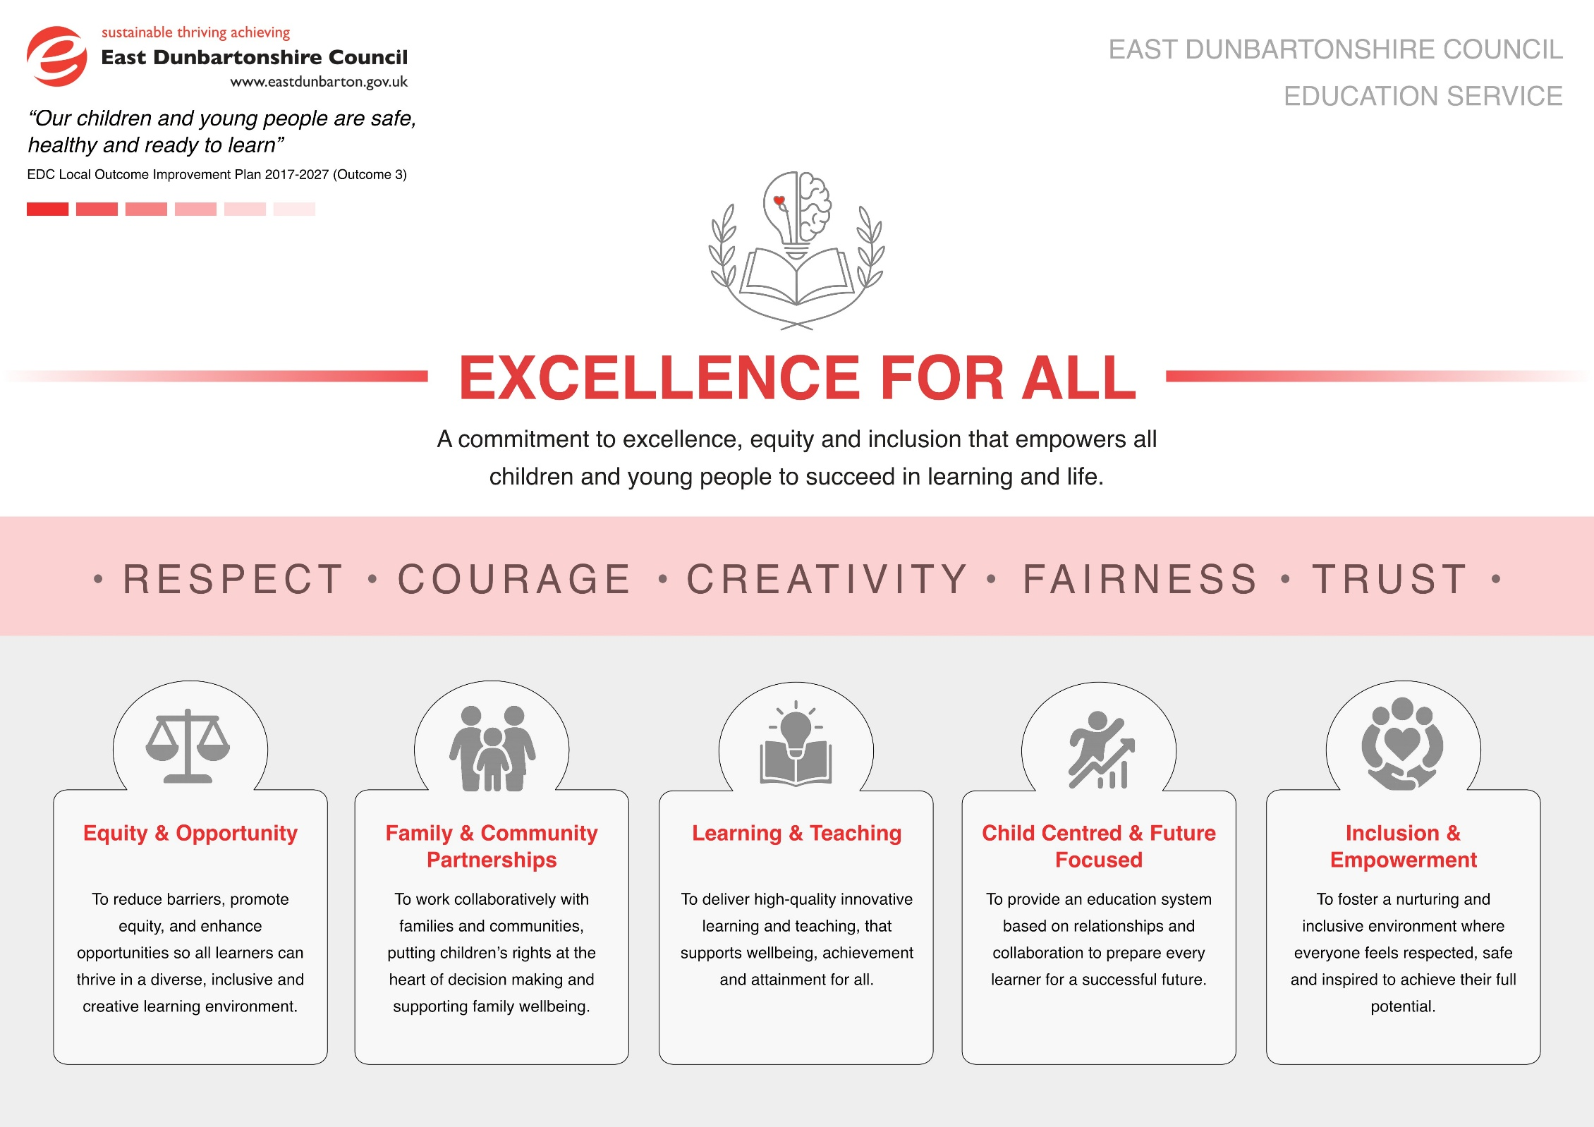
Section 1: School/Establishmnet Information and 3 Year Improvement Plan Priorities
School/Establishment | Colquhoun Park Early Years
Head Teacher/  Depute Head | Claire Loney / Kady Tamburrini
Link QIO | Leona Stewart

School/ Establishment: Vision, Values & Aims and Curriculum Rationale
https://blogs.glowscotland.org.uk/ed/colquhounparkearlyyearscentre/
Current Standards & Quality Report
https://sway.cloud.microsoft/BUAK8fBOB00bGTdn?ref=Link

Looking Forwards – 3 Year Improvement Plan Priorities
Bullet point key priorities for the next 3 years
Session | 2026/27 | 2027/28 | 2028/29
Priority 1 | Wellbeing & Inclusion –  Children’s Rights & Up, Up & Away | Wellbeing & Inclusion | Wellbeing & Inclusion
Priority 2 | Strengthen pedagogical approaches | Curriculum  - CIC Implementation Planning | Pedagogy  - CIC Implementation

Section 2: Improvement Priority 1
School/Establishment | Colquhoun Park Early Years
Improvement Priority 1 | Wellbeing & Inclusion – Children’s Rights & Up, Up & Away
Strategic Leads | SMT  Staff team working party
Education Service Aim |  | IMAGINE Leadership Strategy |  | NIF Priority |  | Quality Framework
Inclusion & Empowerment  Equity & Opportunity  Child Centred & Future Focused |  | Priority 6: Wellbeing & Inclusion  Priority 2: Learning & Teaching |  | Placing the human rights and needs of every child and young person at the centre  Improvement in children and young people’s health and wellbeing |  | Wellbeing, inclusion and equality (HMIE)  Nurturing care and support (CI)  Play and learning (CI)
Opportunities for Leadership |  |  | Resource Requirements |  | Parental Engagement and Involvement
Working parties established - all staff will have the autonomy to self-manage and lead on the implementation of Children’s rights and Up, up and away in centre. |  |  | - Protected time for meetings  - Timelines and mentoring from SMT  - Clerical support when required – resource creation / information sharing |  | - Stay and play sessions  - Home link working  - Family learning opportunities
Professional Learning |  |  | Interventions for Equity |  | Additional Information
- Up, Up & Away & Children’s Rights Training sessions.  - Engagement with documentation  - Collaboration with established centre  - Additional reading  Inservice training on collecting and analysing qualitive and quantitative data to measure progress and impact. |  |  | - high quality learning experience  - early intervention & prevention  - professional learning & leadership |  | - Working parties both independently and together will implement/embed UUA & UNCRC in centre collecting data which will begin to measure the impact on well-being and inclusion within centre.

Outcomes/Expected  Impact for learners; targets; % change | Tasks/Interventions: Activities in Professional Learning  Learning and Teaching interventions | Measures: Identify qualitative, quantitative, evaluative pre and post measures | Timescale(s): Key dates for implementation and measuring impact | Progress | Early Level Meta Skills
Children’s Rights; Staff will have a clear direction of delivery and will do so effectively across centre.  Almost all pre-school children will confidently understand and demonstrate 4 identified rights ‘Right to play’, ‘Right to be heard’, Right to active & healthy’, ‘Right to education’  Almost all children will recognise and identify the children’s rights logo.  Almost all children will know about SIMOA and the ‘Right to be safe from harm’  Early Level Meta Skills: Feeling, communicating, leading, integrity, initiative, critical thinking | Staff will review and evaluate 2025-26 introduction to Rights  Based on information from evaluation working party will create a PDSA for delivery  Group PDR will be carried out to identify training need and support  Staff will continue to integrate the 4 rights identified 2025-26 and embed these into practice ensuring they are identifiable throughout delivery and environment  Rights logo will be used across centre with the backing colour of the right it relates to.  Through the teaching of SIMOA staff will develop children’s knowledge and understanding of the right to be safe. | - Microsoft forms  - PDSA  - PDR  - Observations  - Stakeholder knowledge  - Learning journals  - Discovery logs  - Wall displays  - Working party minutes  - Leadership meeting minutes  - TEAMS TILE  - Social Media  - Blogs  - Newsletter | Implementation  August 2026  Measuring Impact  July 2026 |  | Social Intelligence  Feeling: Recognising that peers have the same rights to feel safe, happy, and included. Communicating: Articulating thoughts, feelings, and choices confidently (Article 12). Leading: Speaking up for fairness or helping peers participate in play (Article 31).  Self-Management  Integrity: Demonstrating fairness, honesty, and respect for shared room charters. Initiative: Exercising choice and ownership over their learning, rest, and personal care.  Innovation  Critical thinking: Assessing whether classroom practices are fair and inclusive for all learners.
Up, Up & Away; All children will have access to books, literacy sacks and signage, further strengthening the link between EYC & Home.  Staff will begin the implementation process of sections 3 - optimise opportunity for the child and section 4 - planning to meet children’s needs from the Up, Up and Away document. Increase knowledge will support staff to identify and deliver individual need based approaches which positively enhancing inclusion and equity for all. | Staff will review and evaluate 2025-26 Up, Up & Away implementation plan.  Based on information from evaluation working party will create a PDSA for next steps of implementation  Group PDR will be carried out to identify training need and support  Staff will be tasked with familiarising themselves with section 3 & 4 of the Up, Up & Away document.  Leadership meetings will discuss plan for moving forward.  Weekly working party meetings to update and designate staff responsibility and shared implementation tasks.  Termly leadership meetings will SLT to feedback to measure termly progress. | - Microsoft forms  - PDSA  - PDR  - Observations  - Stakeholder knowledge  - Learning journals  - Discovery logs  - Wall displays  - Working party minutes  - Leadership meeting minutes  - TEAMS TILE  - Social Media  - Blogs  - Newsletter | Implementation  August 2026  Measuring Impact  July 2026 |  | Early Level Meta Skills:  Innovation  Sense making: Understanding oral instructions, mapping sound patterns, and making sense of nursery routines.  Social Intelligence  Communicating: Articulating choices, sharing ideas, and listening to others using tailored communication supports. Collaborating: Engaging smoothly in peer play because communication barriers have been identified and removed.  Self-Management  Focusing: Maintaining sustained attention during play within a structured, low-distraction environment. Initiative: Exercising autonomous choices because resources and routines are tailored to their developmental level.
Centre’s Vision, Values and Aim will align with and reflect current pedological practice and ethos of Colquhoun Park Early Years Centre. Creating a nurturing, inclusive, and inspiring environment where every child feels valued, safe, and empowered to explore, learn, and reach their full potential. | Staff will consider the centres current pedological practice and ethos.  SLT will meet with sister centres who have developed VVA to gain insight on how this was done effectively, ensuring the process incorporates and creates opportunity for the voice of all stakeholders.  PDSA will be created to document process.  All stakeholders will be given the opportunity to reflect on the centres current VVA and encouraged to have their say.  SLT will collate all information gathered and use this to review current VVA. | - Microsoft forms  - Socials  - Learning Journals  - Stakeholder input  - Newsletter  - Blog  - Wall Display  - Vision, Value, Aims and Ethos statement | Consultation  October 2026  Implementation  January 2027

Section 2: Improvement Priority 2
School/Establishment | Colquhoun Park Early Years
Improvement Priority 2 | Strengthening Pedagogical Approaches
Strategic Leads | SMT  Staff team working party

Education Service Aim | IMAGINE Leadership Strategy |  | NIF Priority |  | Quality Framework
Family & Community Partnerships  Inclusion & Empowerment  Child Centred & Future Focused | Priority 7: Skills for Learning, Life & Work  Priority 5: Partnerships |  | Improvement in skills and sustained, positive school-leaver destinations for all  Placing the human rights and needs of every child and young person at the centre |  | Leadership of continuous improvement (HMIE)  Curriculum (HMIE)  Leadership and manangement of staff and resources (CI)  Play and learning (CI)
Opportunities for Leadership |  | Resource Requirements |  | Parental Engagement and Involvement
- Designated staff (ZM) to take forward Forest Programme & Mini Explorers  - Designated staff to take forward song, story & rhyme (AS) |  | - Green house  - Training sessions  - Equipment audit  - Supporting resources  - Protected time |  | - Bookbug session  - Forest and mini explorer family sessions  - Review of centre Vision, Values & Aims statement
Professional Learning |  | Interventions for Equity |  | Additional Information
- Peer learning opportunities  - Uptake of training offers  - Visits to sister centres promotion of collaborative working  - Understanding Meta Skills full centre initiative |  | - high quality learning experience |  | - Strong focus on upskilling staff curricular knowledge surrounding meta skills  - Staff will consider our pedagogy within centre, questioning if this reflects our current VVA?

Outcomes/Expected  Impact for learners; targets; % change | Tasks/Interventions: Activities in Professional Learning  Learning and Teaching interventions | Measures: Identify qualitative, quantitative, evaluative pre and post measures | Timescale(s): Key dates for implementation and measuring impact | Progress | Early Level Meta Skills
All children will be supported in rhyme recognition  All pre-school children’s confidence development in rhyme generation will be supported.  Almost all pre-school children will know and have the ability to recite at least 10 rhymes | Implement rhyme of the fortnight.  Rhyme will be recited and learned during together times.  Home links created to support learning.  Provocations to be set to support children’s exploration of rhyme  Focussed and pre-planned 1:1 or small group sessions with all children, created considering age/stage appropriateness  Bookbug session dates for 2026-27 shared on family engagement calendar | - Observation  - Literacy Trackers  - Teacher assessments  - Learning journals  - Story, song & rhyme evidence folder  - Child demonstration of skills  - Parental engagement/feedback | Implementation  August 2026  Interim Impact measure  January 2026  Measure Impact  June 2027 |  | Innovation  Critical thinking: Predicting rhyming endings based on context and sound.  Sense making:  Spotting sound patterns and categorising rhyming families.  Social Intelligence Communicating: Enhancing vocabulary, listening skills, and vocal expression. Collaborating: Joining in group rhythm, shared timing, and ring games.  Self-Management Focusing: Holding acoustic patterns in working memory and sustaining attention.
All children will be able to identify the following aspects of a story book  - Front/back cover  - Spine  - Page  - Right to left writing  All pre-school children will be able to describe the role of the  - Author  - Illustrator  - Publisher  All pre-school children will be supported to verbally and pictorially, create their own stories through the talk for writing initiative. | Implement story of the Month  Story will be read and explored during together times.  Home links created to support learning – blooms questions  Provocations to be set to support children’s exploration of story through small world and props  Bookbug session dates for 2026-27 shared on family engagement calendar  Talk for Writing initiative | - Observation  - Literacy Trackers  - Teacher assessments  - Learning journals  - Story, song & rhyme evidence folder  - Child demonstration of skills  - Parental engagement/feedback | Implementation  August 2026  Interim Impact measure  January 2026  Measure Impact  June 2027  Implementation  September 2026  Measure Impact  Termly |  | Innovation  Sense making: Connecting plot points, understanding cause and effect, and mapping new vocabulary.  Critical thinking: Making predictions, drawing inferences, and proposing alternative solutions.  Social Intelligence  Feeling (Empathy): Identifying character emotions and applying perspective-taking.  Communicating: Discussing illustrations, asking questions, and retelling events in sequence.  Self-Management  Focusing: Holding earlier story details in working memory while listening to new plot points.
All staff have a sound understanding of Meta Skills creating the ability for staff to tune into how children manage their own actions and feelings during play, supporting the development of self-management, social intelligence and innovation. | In house introduction programme created for staff Meta skills to staff team.  Link Meta skills into current CIP beginning to create links and use language | - Meta skills training programme  - CPD logs  - Staff knowledge  - Meta skills delivery pack  - Staff questionnaires | Implementation  August 2026  (In-service)  Interim Impact measure  January 2027  Measure Impact  July 2027
Mini Explorer and Forest Programme will be delivered in centre instilling a lifelong care for nature and sustainability where children develop an emotional connection to their local landscape. | Staff member will be allocated to take the lead on implementation and upskilling staff team  SMT and designated person will map out a plan of delivery for 2026-27 ensuring all children can experience this programme. | - Risk Assessments  - Delivery plans  - Registers  - Parental engagement  - Staff CPD | Implementation  September 2026  Impact measured  Termly |  | Self-Management Adapting: Adjusting play when weather changes or a den build collapse. Initiative: Choosing tools and loose natural parts to solve a self-set challenge.  Social Intelligence  Collaborating: Teaming up with peers to move heavy logs or construct group shelters. Communicating: Sharing discovery details and listening to outdoor safety boundaries.  Innovation  Critical Thinking: Evaluating physical risks (e.g., climbing heights, testing branch strength). Creativity: Transforming natural loose parts into imaginative play props.

